**Network commands**

**ip config**

Basic details of system connected to a network

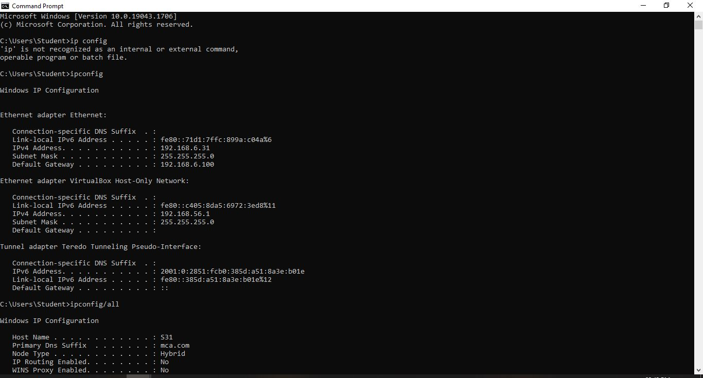

**ipconfig/all**

Detailed study of system connected to network



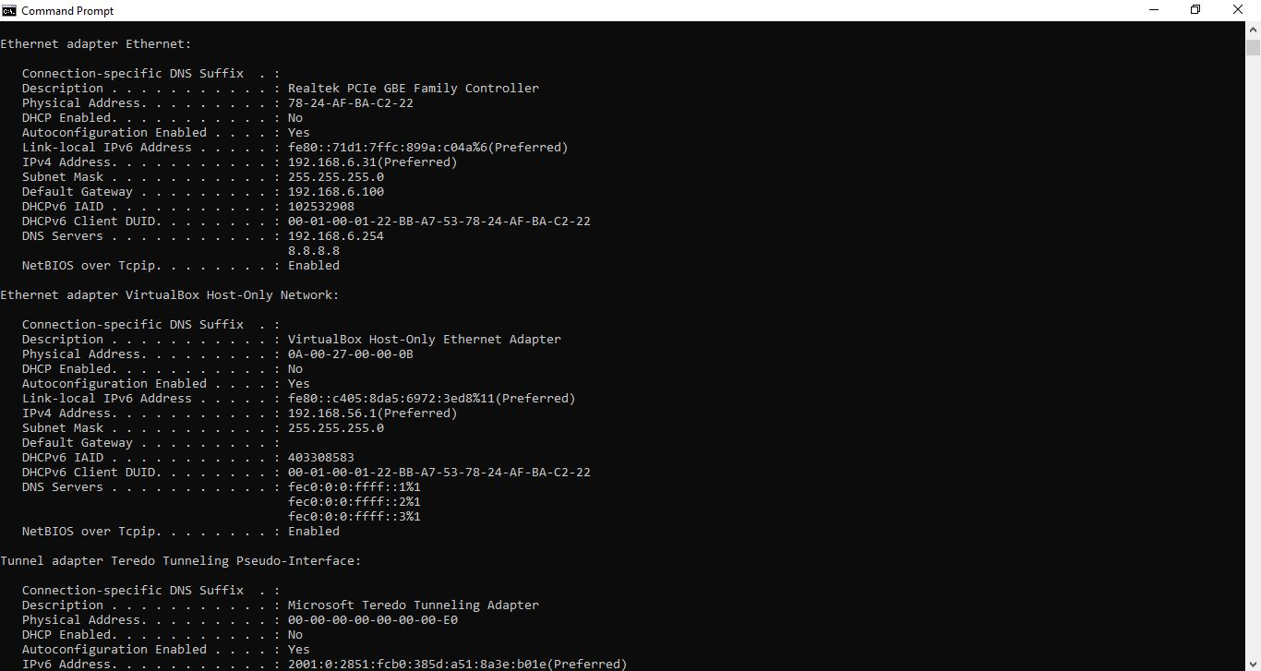

**ping**

identify the destination host

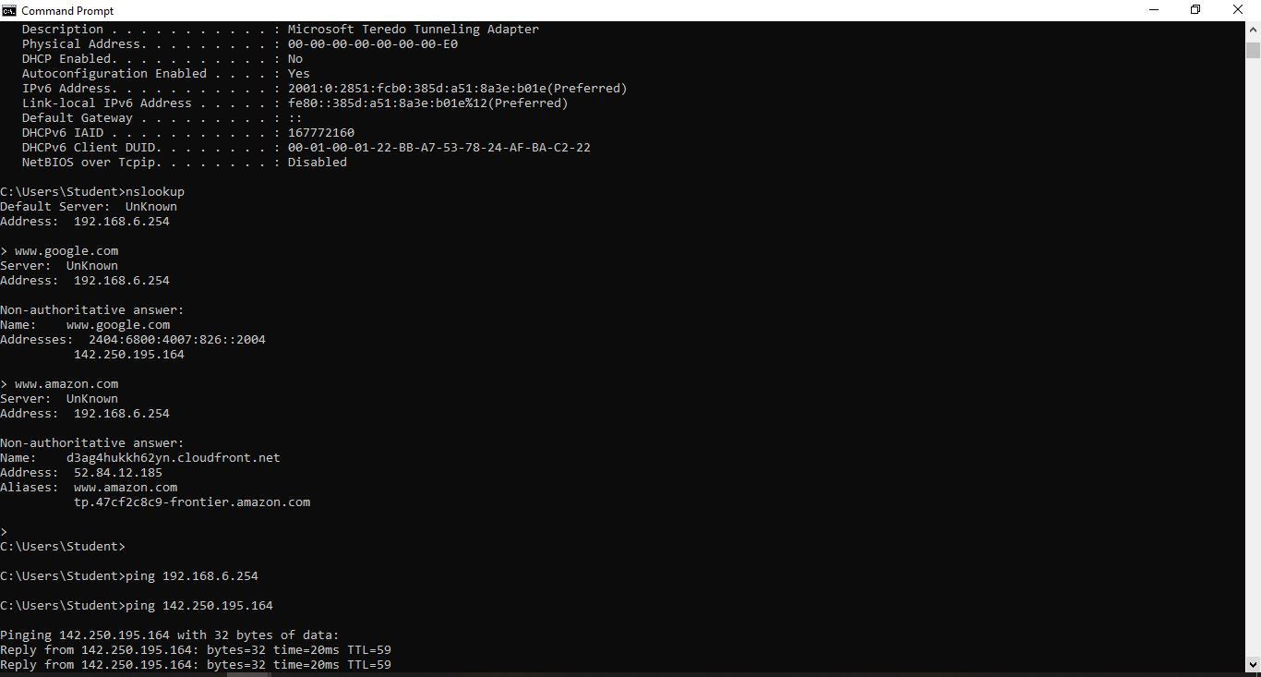

**tracert**

How many router ie needed to overcome to reach destination

traceart “ip address”

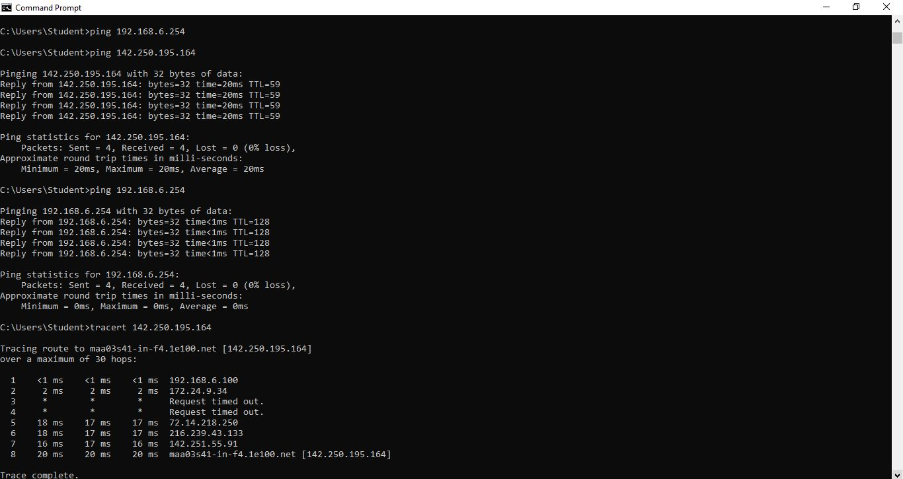

**route print**

to access our system routing table

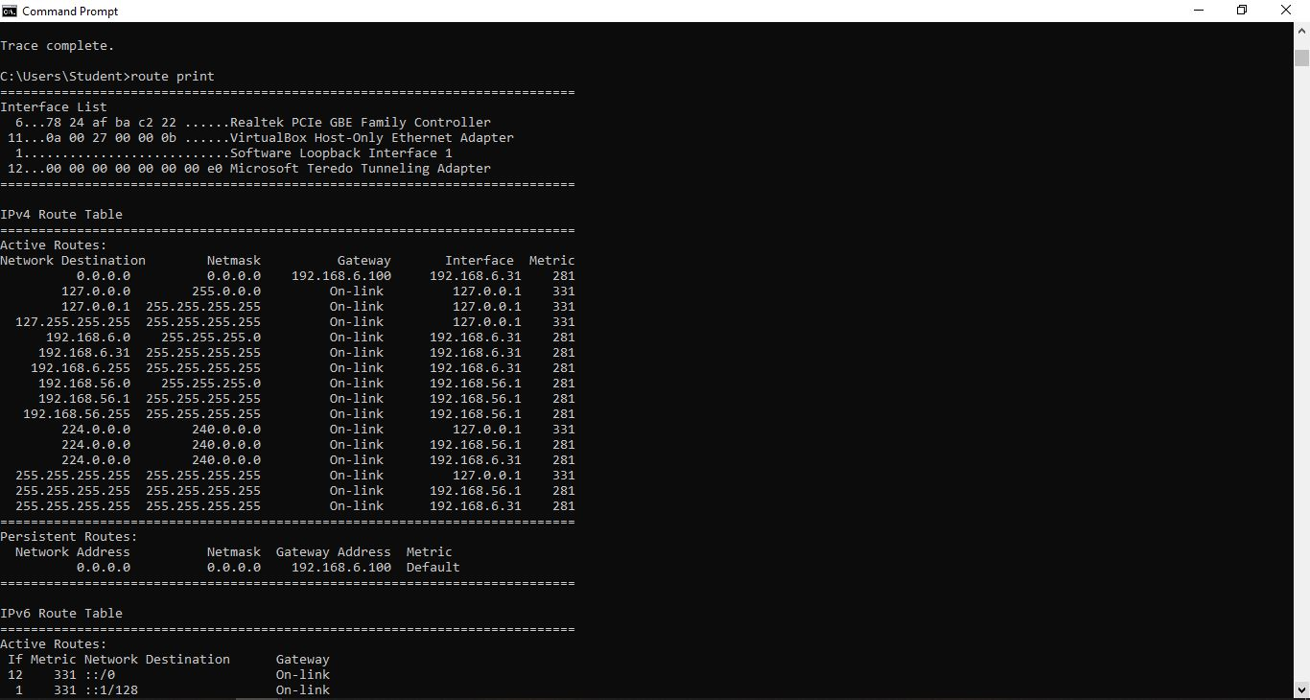

**netstat**

the available number of connection through tcp and udp

